QBUS6810
Statistical Learning & Data Mining

Airbnb Pricing Predictions

Group Assignment
June 08, 2018

Group 50
460319933 | 470035203
460157014 | 470347324
460487531
Table of Contents
1. Introduction 2
2. Data Processing 2
3. Exploratory Data Analysis 3
4. Feature Engineering 5
5. Methodology 5
6. Analysis 6
6.1. Model Stacking 6
6.2. Boosting and Bagging 6
6.2.1. Gradient Boosting 7
6.2.2. Random Forest 7
6.2.3. Bagging 7
7. Conclusion 7
8. References 9

Introduction
The global tourism business is growing at the rate of 10-12% annually. As per 2016, the number of tourist arrivals stands at 1200 million, which is predicted to reach 1800 million by 2030 worldwide. (Statista, 2018). To utilize this fact and gain the competitive advantage in the market, the pricing concerns of tourists for a short-term stay should be fixed. The manual pricing methodology is crucial as it depends on numerous practical factors. This report interprets the model developed for automated optimized pricing for the houses listed in Airbnb using statistical machine learning algorithms.
Two hypotheses were made for this case. The first one is that the given values for pricing are not random, as depends on various qualitative and quantitative factors of the house. Second, the cap for some quantitative variables possesses a sense behind it, without being pointless. The results are finalized based on low Root Mean Square Error Values, since the deviation of these predictions from the regression line data points will be the lowest.

Data Processing
Before conducting any application of models or analysis on a dataset, it is vital to prepare the data. In the given case of Airbnb pricing predictions, there are a total of 28 predictors, also known as the independent variables; on the other hand, there is only one dependent variable that is, the price. The basic purpose of this report is to identify the most appropriate pricing model based on the most important predictors (features) amongst these 28 variables and analyse their effect on our response variable (label), price.
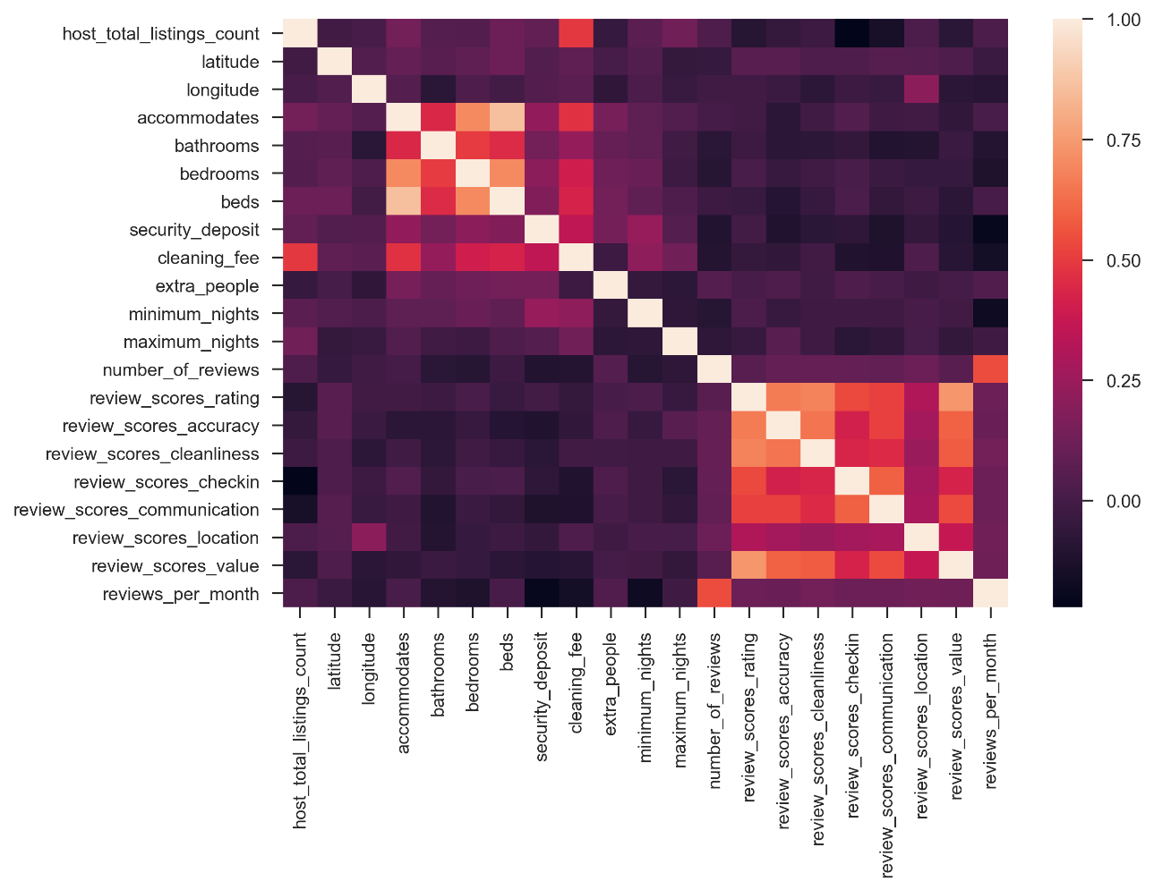
Figure 1: The Heat Map of Correlation Amongst Features
A total of 1000 datapoints are available for the train set; having a high number of datapoints may assist in yielding a more precise result, representing the entire Airbnb, considering the assumption of large numbers holds.
However, a considerable amount of missing values was identified while preparing the data. The environment of Pandas usually determines these values as NaN. Therefore, to fill these missing values from a logical perspective, the missing values were replaced based on the size and nature of the features. In the case of predictors with a small amount of missing values, such as ‘host_is_superhost’, ‘host_total_listings_count’, ‘host_identity_verified’, bathrooms and beds, mode was used instead of mean; this is because mean values are more likely to increase noise for discrete variables. Moreover, non-integer numbers are unreasonable for these features. Then, for other features with a large amount of missing values, different methods were used to fill the NaN values depending on the nature of predictors. As for the group of review scores, all NaN values appear when the values of feature named ‘number_of_reviews’ are 0, 1, 2 or 3; in such a situation, the mean value of each feature could substitute the NaN values. ‘Security_deposit’ and ‘cleaning_fee’ are the two features which were more complicated to deal with in terms of missing values because they are random missing values. On one hand, Figure 1 shows the relatively high correlation between ‘cleaning_fee’ and ‘host_total_listings_count’, ‘accommodates’, ‘bedrooms’ and ‘beds’, which means the simple regression could be applied to predict the missing values and fill them with forecasted values. On the other hand, ‘security_fee’ is more likely to be alone because of the low relation with other features. The simple way is to fill them with the mean value of this feature, but this strong method could penalise the precision of the pricing model. However, eliminating this predictor would also adversely affect the accuracy of the model because of the high correlation with the label.
In addition, several categorical variables were spotted. To deal with these variables, dummy variables were created. For example, there were several types of rooms existing in the data: entire home/apartment, private room, and shared room. Thus, the dummy variable was created as follows: if one of the room type was identified for the listing, then Jupyter Notebook would put that as 1, and the rest of the room types would be put as a 0.
Now that the data preparation has been done, the following chapter will now focus on the exploratory data analysis to discover patterns, study the outliers (if any) and understand the data and the features better.

Exploratory Data Analysis
Exploratory Data Analysis helps in exploring the important features and patterns that exist in the data in the form of visualisation and numerical summaries, before the process of formal modelling begins and sometimes, helps in preventing errors and recognising outliers as well. (The University of Sydney Business School). It assists in informing about the formation of complex statistical models. (Johns Hopkins University, n.d.).
For the case of Airbnb, we first wanted to examine the normality of our response variable price. Figure 2 illustrates the plot of the response variable, price; the skewness towards the right denotes non-normality. To improve on the non-linearity, we transform the prices to log prices (Figure 3). From Figure 2, it is evident that the log transformation has improved the distribution of the data, having most of the concentrated in the centre, resulting in a relatively normally distributed graph.
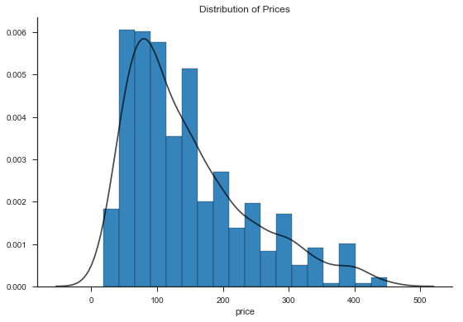  Figure 2: Distribution of Prices | 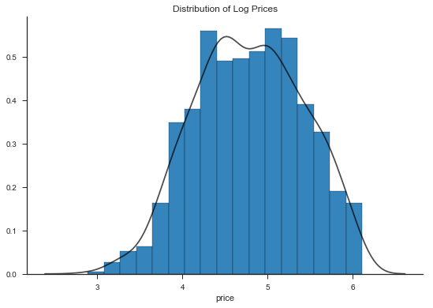  Figure 3: Distribution of Log Prices

Furthermore, to identify the most important predictors that have a significant effect on the response variable, we plotted every predictor individually against price and processed correlations. Based on the outcome of the correlations and from the perspective of the economic logic in the pricing model, the results suggested that security deposit (with a correlation of 0.317) and cleaning fee (0.458) are the most relevant independent variables (Figures 4 and 5). Even though, accommodates has a higher correlation than security deposit and cleaning fee, the model suggested that the latter have a significant effect on price.
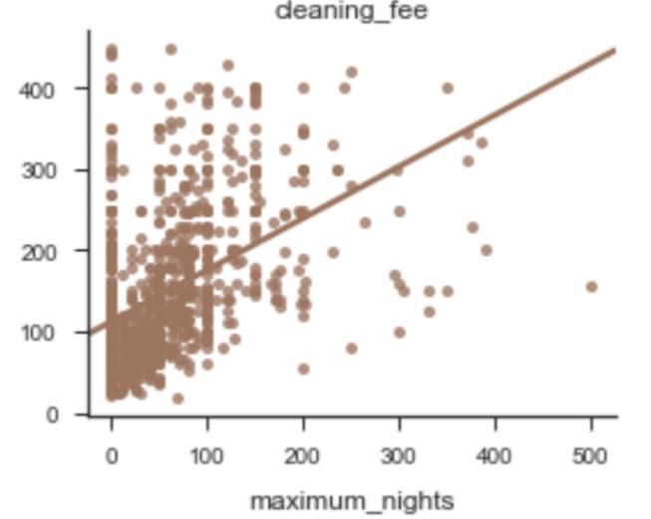  Figure 4: Relationship between Price & Cleaning Fee | 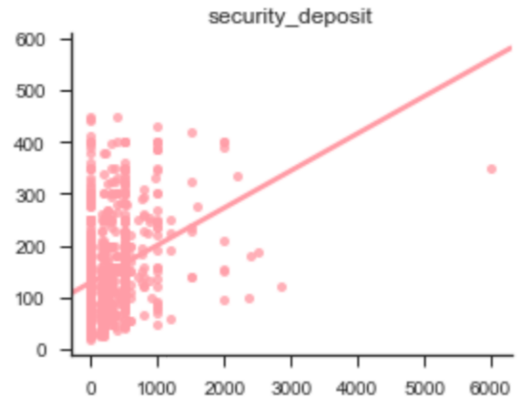  Figure 5: Relationship between Price & Security Deposit
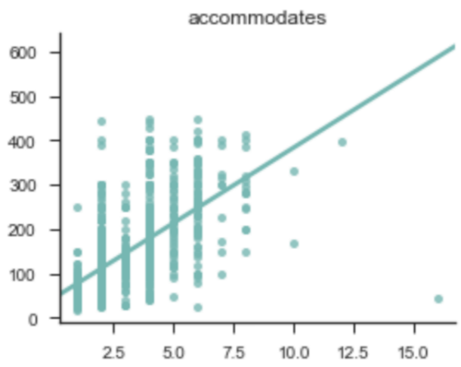  Figure 6: Relationship between Price & Accommodates | 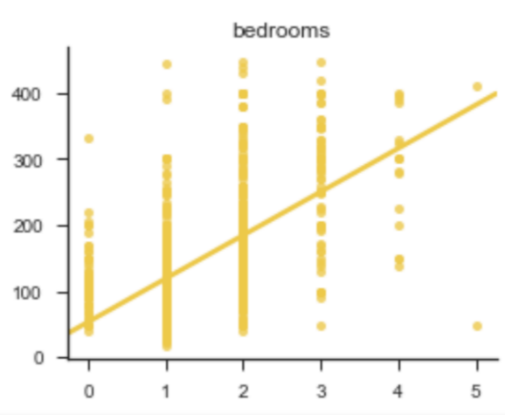  Figure 7: Relationship between Price & Bedrooms
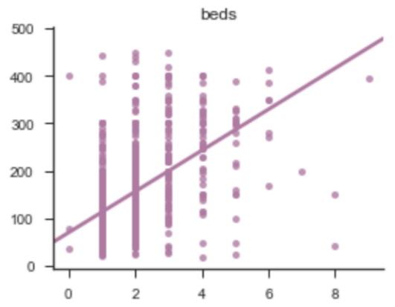
Figure 8: Relationship between Price & Beds
Furthermore, the results of the correlation suggested that accommodates (0.625), bedrooms (0.574), and beds (0.532) are strongly related to price. On the contrary, when it comes to the other predictors, the low correlation rate and their minimal effect on the pricing model resulted in the elimination of those predictors as these possessed low predicting value. These variables portray a positive linear relationship (Figures 4, 5, 6, 7 and 8 potentially leading to a promising analysis of the model. The chosen predictors would be elaborated upon in the forthcoming chapter, where their selection would be justified, based on the way these features have been engineered and further used in the models.

Feature Engineering
The aim of feature engineering is to transform processed data into useful features that improve the accuracy of the predictive pricing model in the next chapter. Feature engineering contains three sub-problems, feature extraction, feature selection and feature construction. In our case, we just focus on feature selection to automatically choose important features through regularisation method, lasso.
Lasso performs better on variable selection due to shrinking some coefficients toward zero, especially when there are a few predictors with large coefficients, while the remaining predictors have small or zero coefficients. The bar chart on figure 8 demonstrates the first twenty features based on the size of correlation coefficients. With reference to this, ‘room_type_Entire home/apt’, ‘room_type_Shared room’, ‘accommodates’, ‘longitude’, ‘bedrooms’, ‘cleaning_fee’, ‘review_scores_location’, ‘security_deposit’, ‘minimum_nights’ and ‘review_scores_value’ could be used to fit our pricing model and predict the price. After finishing the data processing and feature engineering for the train set, the same operation will be applied to the features of the test set for the forecast in the forthcoming chapter.
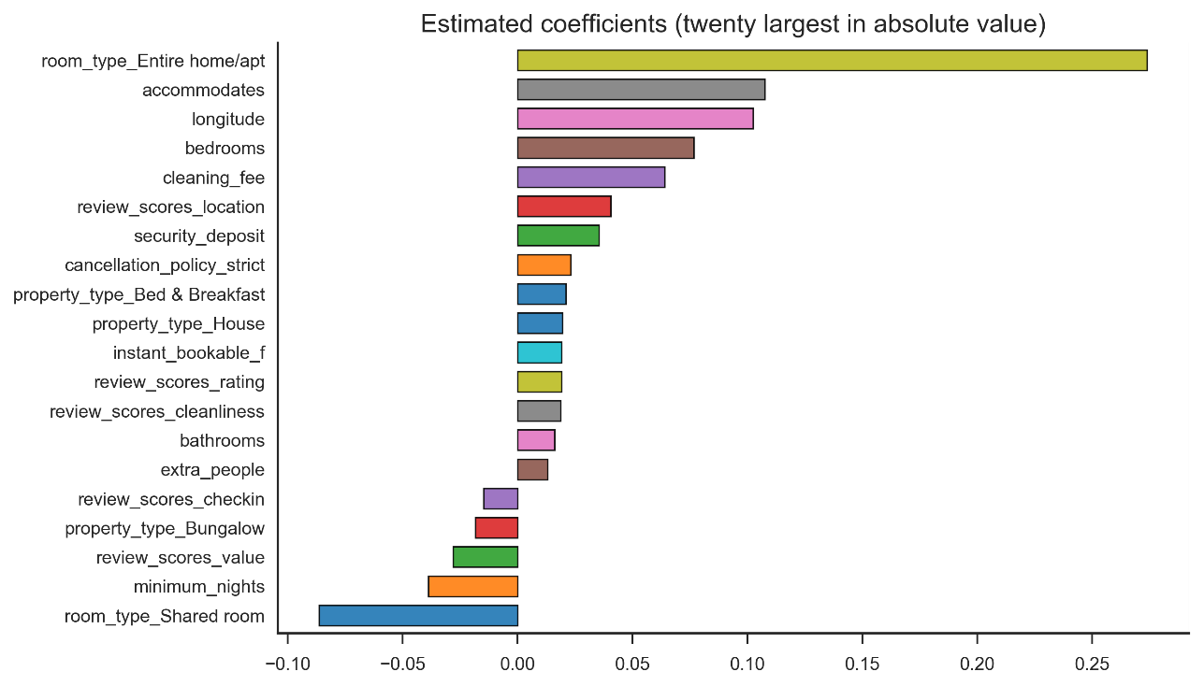
Figure 9: The Coefficient of the First 20 Predictors Based on Lasso

Methodology
The final model that we choose for the pricing model in this report is model stacking. To be specific, the base models are bagging, random forest, gradient boosting using XGBoost, gradient boosting using LightGBM; the 2nd–level model is linear regression. The three reasons for choosing model stacking as our final model have been discussed below.
Firstly, there is no strict restriction on the selection of the base model. In our case, we choose bagging, random forest and gradient boosting as our base models, as the other methods such as regression tree have a low estimating performance and are far away from the base models. However, these base models are quite similar, for example, bagging is a special case of random forest and gradient boosting is achieved by two different algorithms, XGBoost and LightGBM.
Secondly, model stacking usually improves the predictive accuracy, in comparison to using a single method since the stacked model will highlight every single base model where it performs best and discredit every single base model where it performs poorly (Gorman, 2016). In our situation, model stacking does increase the accuracy of predictions when compared to each individual model. Judging from the RMSE (root mean squared error), model stacking shows minimal value which is 59.30128, while the RMSE of bagging, random forest and gradient boosting are 60.97443, 60.97443 and 59.54212 respectively.
Finally, in comparison to model averaging, which chooses the weights via least squares
$\min_{w_{1},…,w_{m}}{\sum_{i=1}^{n}{{(y_{i}-\sum_{m=1}^{M}{w_{m}{\hat{f}}_{m}(x_{i}))}}^{2}}}$, model stacking avoids overfitting. This is because model stacking determines the weights by minimising the formula:
$\min_{w_{1},…,w_{m}}{\sum_{i=1}^{n}{{(y_{i}-\sum_{m=1}^{M}{w_{m}{\hat{f}}_{m}^{-i}(x_{i}))}}^{2}}}$, where ${\hat{f}}_{m}^{-i}$ is a regression function that is estimated the same way as ${\hat{f}}_{m}$ but, with the $i$-th observation removed. In this case, model stacking takes the complexity of each merged models into consideration and does not put too much weight on the most complex models which has low errors in the training set.
The completion of the process of model stacking involves four steps:
Step 1: Randomly splitting the training data (1000 values) into 10 folds of approximately equal size (around 100 values).
Step 2: For each fold $k∈\left\{1,2,3,4,5,6,7,8,9,10\right\}$, estimating the first model (bagging) on the rest of the combinations of folds, and using fold k to predict price. After this step, we will get $100×10$ estimated prices which is equivalent to the number of training data. These estimated prices denote $P_{1}$.
Step 3: Repeating step 2 by using the other three models respectively and denoting these different set of estimated prices as $P_{2}, P_{3}, P_{4}$.
Step 4: ${P_{1}, P}_{2}, P_{3}, P_{4}$ , $1000×4$ estimated prices, are stacked and provided to the 2nd–level model (meta-regressor), which is linear regression, and the model with the better performance will be allocated a higher weight. As mentioned earlier, when determining model weights, the regression function is estimated the same way as ${\hat{f}}_{m}$ but with the $i$-th observation removed. Therefore, we obtain the final model stacking.
Step 5: Estimating prices on test set by using the final model stacking.

Analysis
In this assignment, there are five methods in total applied to make the prediction of Airbnb price. The five models include model stacking, gradient boosting, random forest and bagging. Unsurprisingly, model stacking provides the best prediction result in both train set and test set, following by …..(shown as the figure below)

Model Stacking
Model stacking is a meta-model which combines several models with estimated optimal weights, leading to a better forecasting performance. (Hastie, Tibshirani, & Friedman, 2016).
Compared to the other four forecasting methods that are used in this assignment, model stacking, as the second level model, does a weighted regression of the basic level methods and weighs the different basic models by their outputs. By doing so, the accuracy of output could be improved, and this is the main reason why the model stacking outperforms the other prediction models.

Boosting and Bagging
Both boosting, and bagging are ensemble models in machine learning, applied in statistical classification and regression. Hastie, Tibshirani and Friedman (2016) pointed out that the performance of random forests is very similar to the performance of boosting in most situations since they are simpler to train and tune. In terms of the difference between boosting and random forest, boosting combines many weak learners in a chronological and adaptive manner, which is high bias and low variance, while random forest is based on the fully-grown decision tree, which is low bias and high variance. Hence, boosting focuses on bias reduction, and random forest focuses on variance reduction.

Gradient Boosting
Gradient boosting, an optimizing technique, is one of the stage-wise additive model aiming to minimize the loss of the model via addition of weak learners using a gradient descent. (Hastie, Tibshirani, & Friedman, 2016). That is, every time the weak learner is added, the existing weak learners (gradient boosting usually uses decision tree as the weak learner.) in the model remains unchanged. There are some implementations of this method in the literature, including XGBoost, LightGBM.
In comparison to random forest, there are two main reasons that make the prediction result provided by gradient boosting better than that of the random forest. The first is that gradient boosting repeatedly trains trees or the residuals of the previous predictors while random forest overfits a sample of the training data and then reduces the overfitting by simply averaging the predictors. Secondly, the hyper-parameters like tree depth in gradient boosting can be tuned while random forest fails to do so (Tirthankar, 2018).
However, the main restrictions of gradient boosting are that the gradient boosting is a greedy algorithm and that it is likely to overfit a training dataset (Brownlee, 2016)

Random Forest
Random forests improve over bagging which builds a large collection of de-correlated trees, and then averages them. (Hastie, Tibshirani, & Friedman, 2016). The idea of random forests is to decrease the variance of bagging through reducing the correlation between the trees, implementing in the tree-growing process through random selection of the input variables.
Since the decision trees are greedy, there are structural similarities in the decision trees. Because of this, the predictions provided by bagging have high correlation (Brownlee, 2016). Being an improvement for bagging, random forest reduces the correlation of the bagging method. Therefore, the prediction performance of random forest is better than that of bagging.
For reducing the bias as much as possible, random forest requires massive and unpruned trees since it fails to reduce the bias. Even worse, its bias is slightly higher than the bias of individual tree in the forest.

Bagging
Bagging, also known as bootstrap aggregating, is one of the ensemble methods in the community of machine learning. It reduces its variance by averaging the predictions over a collection of bootstrap samples. By doing so, bagging significantly improves the stability and accuracy of regression and classification models. Although its ideal candidates are decision trees, bagging also can be applied in other types of methods, such as statistical classification and regression. In our case, the regression tree is simply fitted many times to bootstrap- sampled versions of the data set and average the result. (Hastie, Tibshirani, & Friedman, 2016).
The improvements in prediction obtained by bagging is solely a result of reducing variance as the randomization and reducing sample space impose restrictions.

Conclusion
In order to develop the best model for accurate prediction of nightly prices, model stacking is preferred, as it provides the lowest RMSE of all methods developed.
Our model carries quite a few limitations. To begin with, the variables are selected based on the correlation coefficient values greater than 0.2 between dependent and independent variables. We presume that these values remain constant for a long-time period. The uncertainty level for this assumption is high, which leads to the fact that the variable selection is required from time to time. Secondly, variable elimination is also performed with correlation coefficient values. As a result, there may be consequences of an omitted variable bias which affects the prediction accuracy.
To develop a more stable model in the future for which the prediction accuracy remains steady over a long period, Time Dummy variables method can be used. It compensates the dynamic change of variable importance with time. As the main motive of the case is about the prediction of nightly prices, lesser time is consumed for variable selection, which leads to a complex model. For a different motive, a simpler model would be developed with a high quality of variable selection. Although the predicted model is considered to contain few drawbacks, it can produce a satisfactory accuracy of nightly price prediction for Airbnb based on the Kaggle score achieved.

References
Brownlee, J. (2016, 09). A Gentle Introduction to the Gradient Boosting Algorithm for Machine Learning. Retrieved from machinelearningmastery: https://machinelearningmastery.com/gentle-introduction-gradient-boosting-algorithm-machine-learning/
Gorman, B. (2016, 12 27). The Official Blog of Kaggle.com. Retrieved 6 7, 2018, from A Kaggler's Guide to Model Stacking in Practice : http://blog.kaggle.com/2016/12/27/a-kagglers-guide-to-model-stacking-in-practice/
Hastie, T., Tibshirani, R., & Friedman, J. (2016). The Elements of Statistical Learning: Data Mining, Inference, and Prediction. New York: Springer.
Johns Hopkins University. (n.d.). Exploratory Data Analysis. Retrieved from Coursera: https://www.coursera.org/learn/exploratory-data-analysis
Statista. (2018). Projected international tourist arrivals worldwide from 1995 to 2030, by region (in millions). Retrieved from Statista: https://www.statista.com/statistics/209349/forecast-number-of-international-tourist-arrivals-worldwide-by-region/
The University of Sydney Business School. (n.d.). Statistical Learning & Data Mining: Linear Regression. The University of Sydney.
Tirthankar, G. (2018, 02). Difference between random forest and Gradient boosting Algo. Retrieved from Linkedin: https://www.linkedin.com/pulse/difference-between-random-forest-gradient-boosting-algo-goon
Trevor Hastie, R. T. (2016). The Elements of Statistical Learning Data Mining, Inference, and Prediction. Springer.

